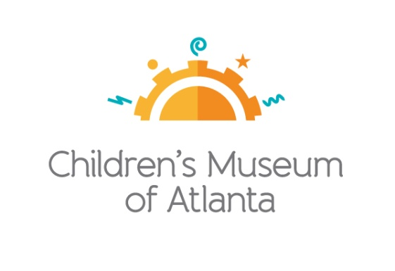
FOR MORE INFORMATION:
Sarah Wynn Benton
BRAVE Public Relations
404.233.3993
sbenton@emailbrave.com

*MEDIA ADVISORY*
Children’s Museum of Atlanta Holds Annual Benefit Gala Supporting the Museum’s Mission, March 23
Tickets and sponsorships available to purchase for charity ball
ATLANTA (March 4, 2024) – The 2024 Imagination Ball, an adults-only charity event aimed at making play-based learning accessible to children from all walks of life, will be held on March 23. Imagination Ball, chaired by Museum board members Andrew Chang and Dr. DeRetta Rhodes, promises an enchanting evening filled with awe, playfulness and exploration. Taking place Saturday, March 23 from 7-11 p.m. at The Eastern in Reynoldstown, the festivities aim to rekindle guests' appreciation for the impact of imagination, fantasy and storytelling. Attendees will indulge in passed hors d'oeuvres and cocktails, while enjoying captivating performances and interactive experiences that evoke the pure joy of childhood play. This annual charity event, featuring an exquisite seated dinner and a live auction, lends its support to the Museum's mission of changing the world by igniting the imagination, curiosity and learning of every child through the magic of play. Tickets and sponsorships can be purchased at bit.ly/ImaginationBall2024.
WHAT: Imagination Ball 2024
Patrons will enjoy live performances, a seated dinner, live auction and more

WHEN: Saturday, March 23
7 – 11 p.m.

WHERE: The Eastern
777 Memorial Drive SE, Building C
Atlanta, GA 30316

HOW: Tickets, sponsorships and raffle tickets are available for purchase online at bit.ly/ImaginationBall2024. Raffle tickets are $100. Event ticket and sponsorship prices vary. Cocktail attire is required.

For more information or to support Children's Museum of Atlanta,
visit childrensmuseumatlanta.org or call 404.659.KIDS [5437]

###

